# Introduction

It is the aim of this report to provide the client with an understanding of where the current system is in terms of development. This report will cover the delivery cycles to come and how the current delivery cycle 1 fits into the overall build of the system. Secondly the current version of the system will be explained with the completed functions and their descriptors. Lastly the report will allow for the client to provide some feedback and or acceptance with regards to the completed functions.

# Delivery Cycle Overview

# Overall Delivery Cycle Plan

# Current Delivery Cycle Plan

The five deliverables for DC1 are as follows:

1. Customer Login
2. Customer reset password
3. Customer register
4. Admin login
5. Admin reset password
6. Admin view users

There has been one change to the delivery cycle plan, the addition of the View Users function for the admin. This function allows for the admin to view the list of all users currently registered.

## Customer Login – Function 1

The customer login function will take a username and password. This will require a valid email address and password. In the event of incorrect login credentials an error message will be displayed prompting the user to try again.

Customers wanting to log in will be prompted for their login credentials shown below: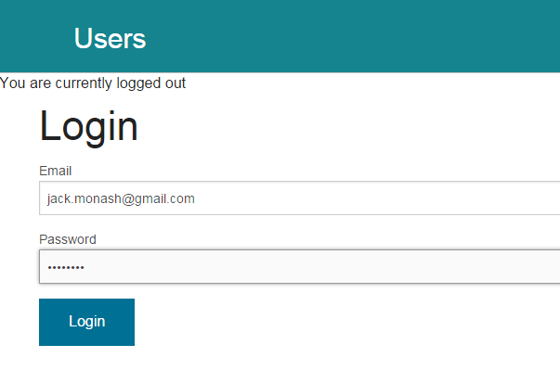

Once credentials have been inputted the customer will click “Login”. If the correct credentials are inputted then the customer will be brought to the home screen shown below and welcomed:



In the event of incorrect login credentials, the customer will be presented with an error message and then prompted to try logging in again with the correct credentials. Shown below:

## Customer Reset Password- Function 1

Similarly to how customers register, they will be prompted to fill out a form. Through this form they are also required to provide some credentials, such as name, email address and if applicable a previous password they can remember.

## Customer register – Function 3

Customers are prompted to fill out a form which asks for their Email (Username) password and personal details. Customers are required to fill in everything that has a red asterisk. The form is shown below.

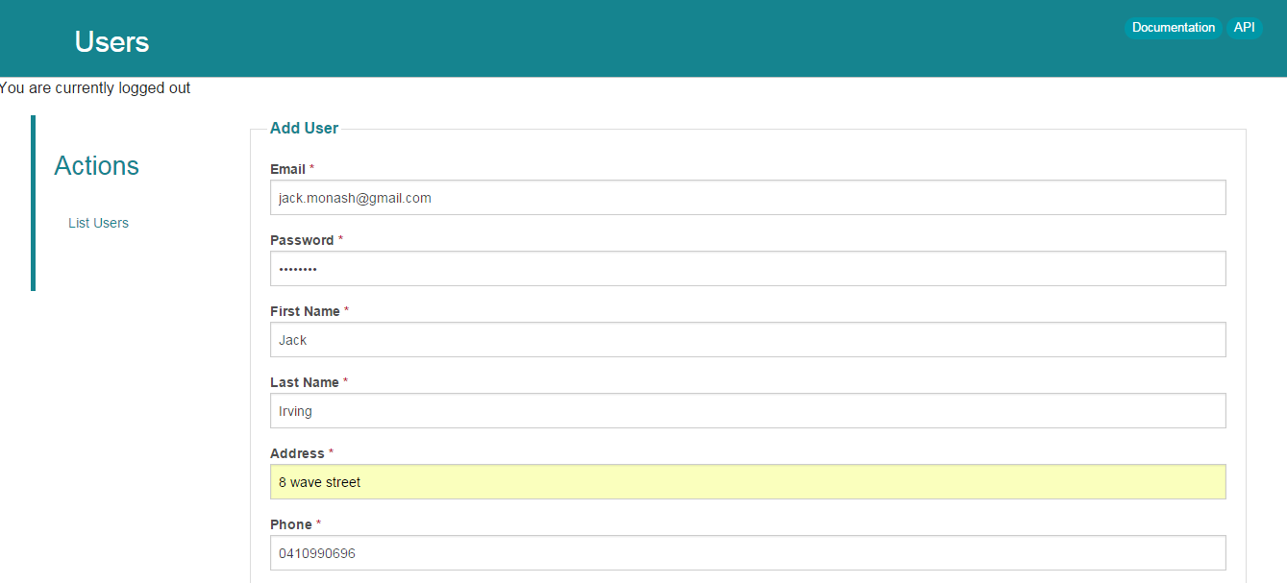

# Admin log in – 4

An admin wanting to log in will need to input their credentials into the log in fields. This is the same login screen as customers see. An example of an Admin wanting to log in is shown below:

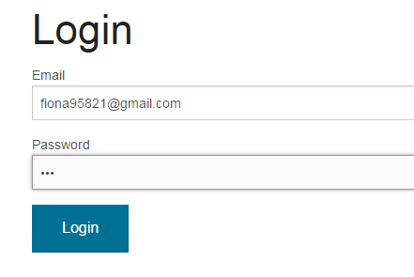

Once the Admin inputs their credentials they should click “log in” and will be taken to the home screen. In this scenario the welcome message is hello admin1 in the live version it will be set to whatever the client would like. The log in page for the admin is shown below: 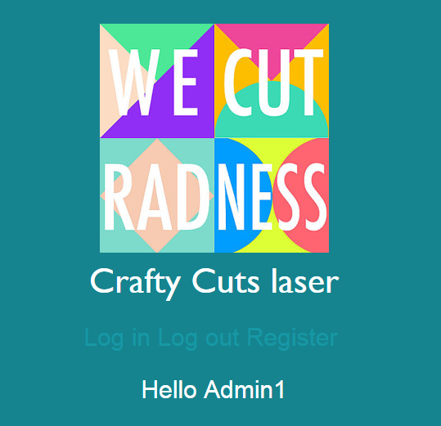

# Admin password rest – Function 5

# Admin list users & add users – Function 6 &7

An Admin can click on list users to see a list of all the users currently registered. This is shown below:

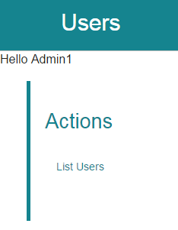

From here Admins can add users this .

## Unauthorized access

In the event a customer or user of the website would like to access a part of the site that’s protected they will be presented with an unauthorized message shown below:

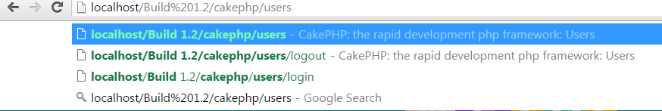

They will then be brought to the login screen and presented with an error. The user can then chose to log in or return to the home page and register. This is shown below:

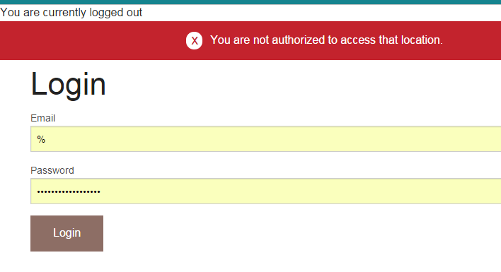

# Appendix